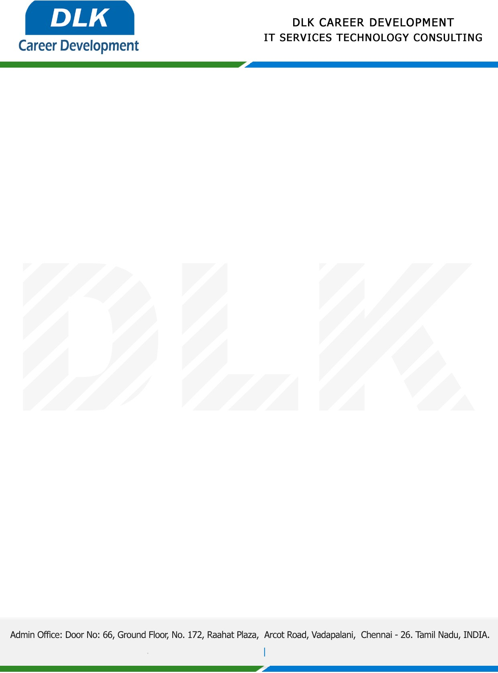

**Date: 23/ May /2023**

**SUB: PROJECT COMPLETION CERTIFICATE**

This is to certify that **MR SHANMUGANATHAN S (REG NO:** **2113092037137) MCA- Computer Application,** final year student **Dwarka Doss Goverdhan Doss Vaishnav College, Chennai** has Successfully Completed the Project Work under the domain of “**Java”** in our organization during the Period **January 2023 to May 2023).**

**Topic:** Multi-purpose agricultural web application using Java.

We appreciate your interest in **DLK CAREER DEVELOPMENT**

**“Best Wishes for Your Future Endeavors “**

